**Summarise From Youtube**

* Search for YouTube Summary with ChatGPT

<https://chromewebstore.google.com/detail/youtube-summary-with-chat/nmmicjeknamkfloonkhhcjmomieiodli>

* Click Add to Chrome (Google Chrome Extension)

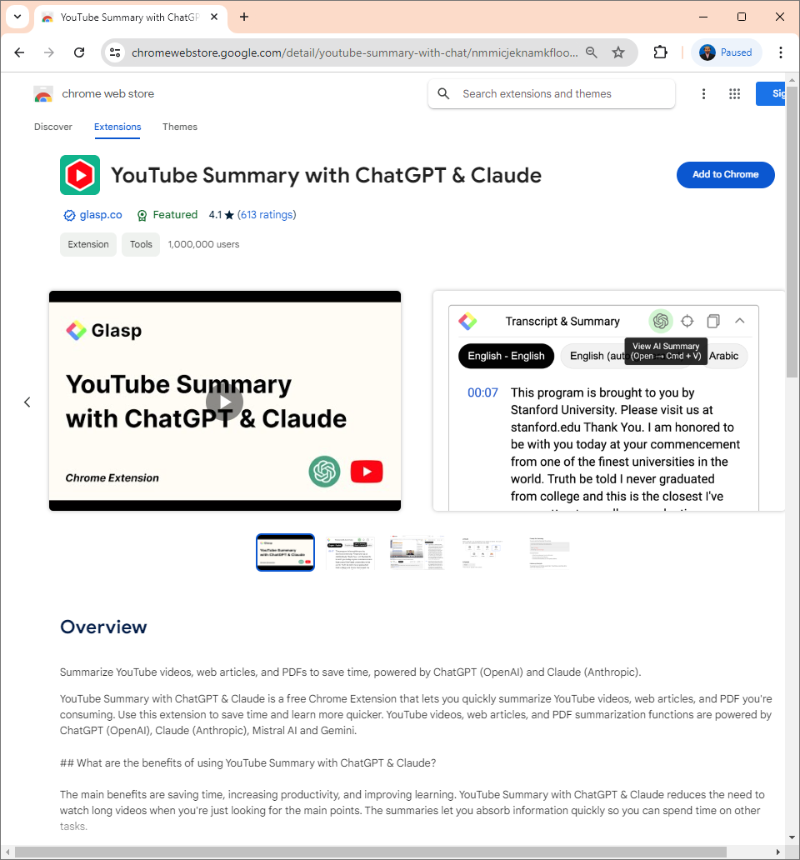

* Click Add Extension

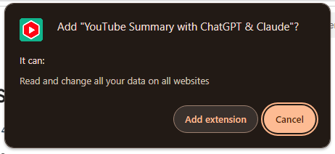

* Click Extensions (in Google Chrome tab menu) and activate Pin for YouTube Summary extension

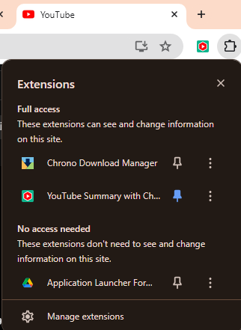

* Select desired AI Model (you can leave it as Default if you are using ChatGPT).
* Insert Prompt for the AI search in Prompt for Summary. For this example, we will use “Ringkaskan kataunci bagi video ini. Senaraikan semuanya.”  
  (“Summarize key point for this video. List all of it.”)

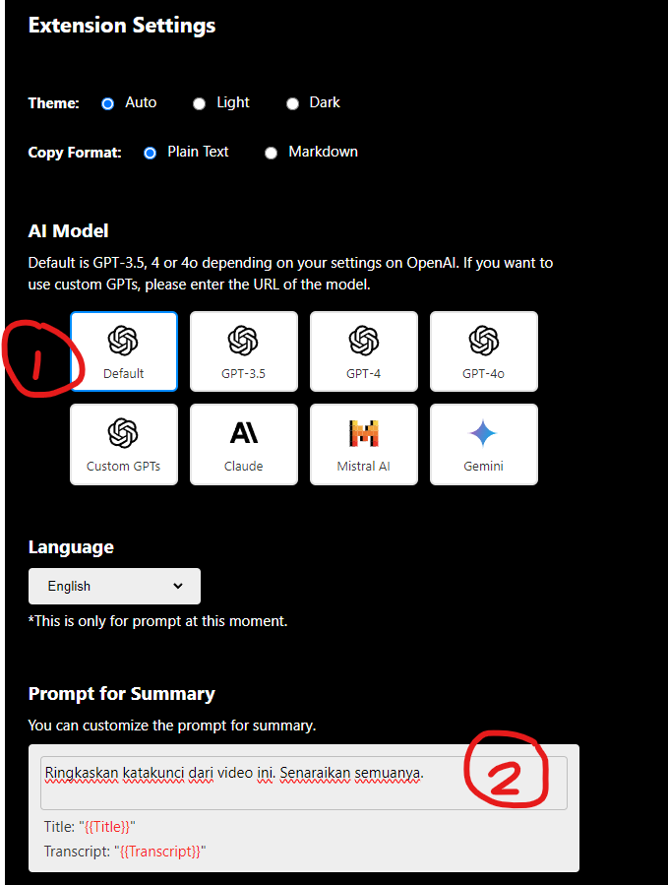

* Search for desired video from Youtube. From the Transcript & Summary bar (right sidebar), click Summarize Video button.

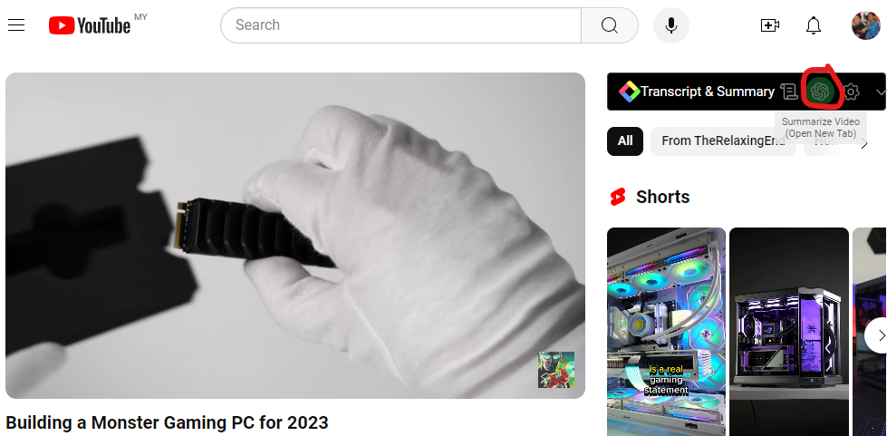

* The extension will launch a new ChatGPT (or other setup AI model) and start the AI summary for the video.

